Bootstrap 5 Buttons

Button Styles

Bootstrap 5 provides different styles of buttons:

**Example :**

<body>

<div class="container mt-3">

<h2>Button Styles</h2>

<button type="button" class="btn">Basic</button>

<button type="button" class="btn btn-primary">Primary</button>

<button type="button" class="btn btn-secondary">Secondary</button>

<button type="button" class="btn btn-success">Success</button>

<button type="button" class="btn btn-info">Info</button>

<button type="button" class="btn btn-warning">Warning</button>

<button type="button" class="btn btn-danger">Danger</button>

<button type="button" class="btn btn-dark">Dark</button>

<button type="button" class="btn btn-light">Light</button>

<button type="button" class="btn btn-link">Link</button>

</div>

</body>

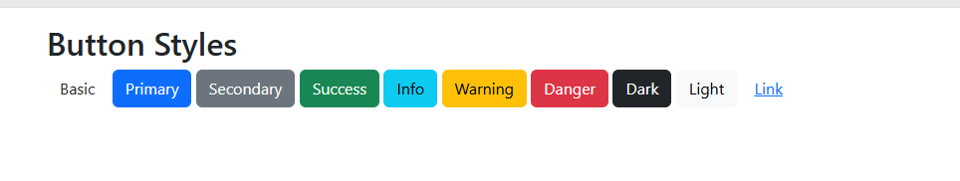

The button classes can be used on <a>, <button>, or <input> elements:

**Example**

<body>

<div class="container mt-3">

<h2>Button Elements</h2>

<a href="#" class="btn btn-success">Link Button</a>

<button type="button" class="btn btn-success">Button</button>

<input type="button" class="btn btn-success" value="Input Button">

<input type="submit" class="btn btn-success" value="Submit Button">

<input type="reset" class="btn btn-success" value="Reset Button">

</div>

</body>

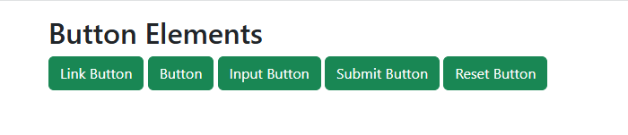

**Button Outline**

Bootstrap 5 also provides eight outline/bordered buttons.

Move the mouse over them to see an additional "hover" effect:

<button type="button" class="btn btn-outline-primary">Primary</button>

<button type="button" class="btn btn-outline-secondary">Secondary</button>

<button type="button" class="btn btn-outline-success">Success</button>

<button type="button" class="btn btn-outline-info">Info</button>

<button type="button" class="btn btn-outline-warning">Warning</button>

<button type="button" class="btn btn-outline-danger">Danger</button>

<button type="button" class="btn btn-outline-dark">Dark</button>

<button type="button" class="btn btn-outline-light text-dark">Light</button>

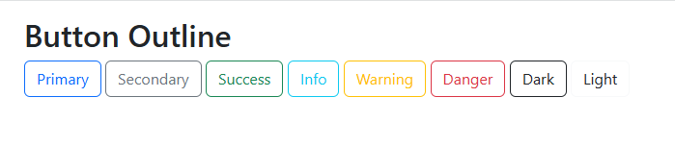

**Button Sizes**

Use the .btn-lg class for large buttons or .btn-sm class for small buttons:

<h2>Button Sizes</h2>

<button type="button" class="btn btn-primary btn-lg">Large</button>

<button type="button" class="btn btn-primary btn-md">Default</button>

<button type="button" class="btn btn-primary btn-sm">Small</button>

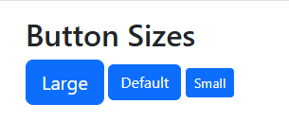

**Block Level Buttons**

To create a block level button that spans the entire width of the parent element, use the .d-grid "helper" class on the parent element:

<div class="container mt-3">

<h2>Block Level Buttons</h2>

<p>To create a block level button that spans the entire width of the parent element, use the .d-grid "helper" class on the parent element:</p>

<div class="d-grid">

<button type="button" class="btn btn-primary btn-block">Full-Width Button</button>

</div>

</div>

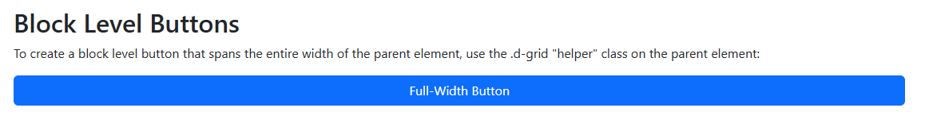

If you have many block-level buttons, you can control the space between them with the .gap-* class:

<div class="container mt-3">

<h2>Block Level Buttons</h2>

<p>If you have many block-level buttons, you can control the space between them with the .gap-* class:</p>

<div class="d-grid gap-3">

<button type="button" class="btn btn-primary btn-block">Full-Width Button</button>

<button type="button" class="btn btn-primary btn-block">Full-Width Button</button>

<button type="button" class="btn btn-primary btn-block">Full-Width Button</button>

</div>

</div>

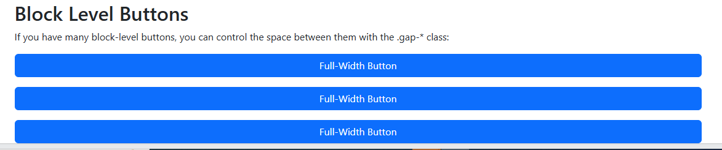

**Active/Disabled Buttons**

A button can be set to an active (appear pressed) or a disabled (unclickable) state:

<div class="container mt-3">

<h2>Button States</h2>

<button type="button" class="btn btn-primary">Primary Button</button>

<button type="button" class="btn btn-primary active">Active Primary</button>

<button type="button" class="btn btn-primary" disabled>Disabled Primary</button>

<a href="#" class="btn btn-primary disabled">Disabled Link</a>

</div>

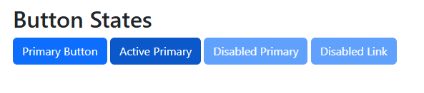

**Spinner Buttons**

<div class="container mt-3">

<h2>Spinner Buttons</h2>

<p>Add spinners to buttons:</p>

<button class="btn btn-primary">

<span class="spinner-border spinner-border-sm"></span>

</button>

<button class="btn btn-primary">

<span class="spinner-border spinner-border-sm"></span>

Loading..

</button>

<button class="btn btn-primary" disabled>

<span class="spinner-border spinner-border-sm"></span>

Loading..

</button>

<button class="btn btn-primary" disabled>

<span class="spinner-grow spinner-grow-sm"></span>

Loading..

</button>

</div>

